|  |
| --- |
| **Huddle work instruction** |

Open and Login

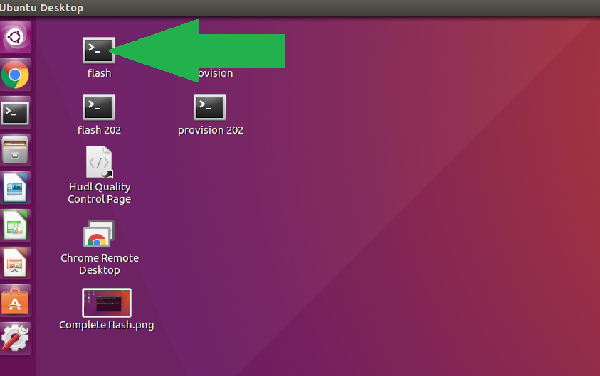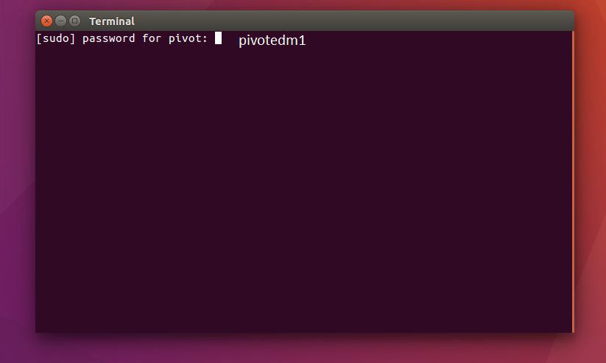

Connect cables to PCB

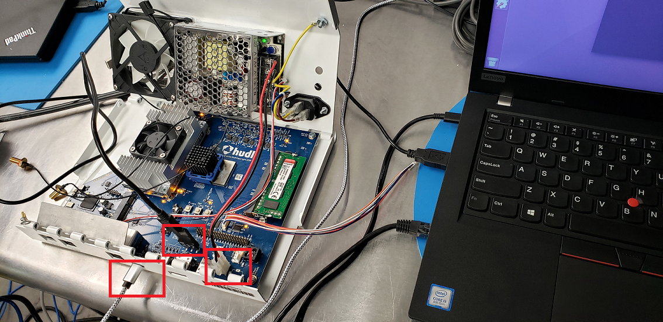

Flashing process

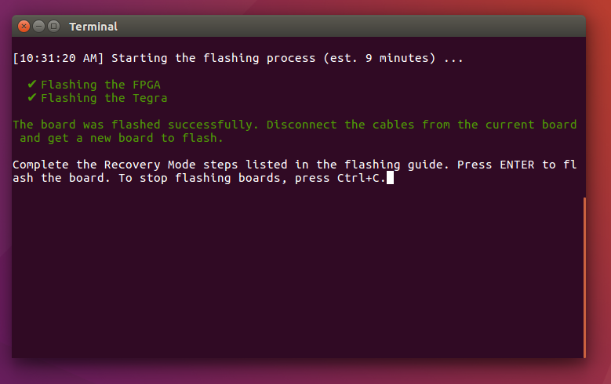

Remove Label

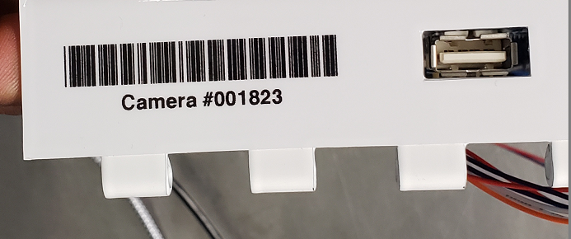

|  |
| --- |
| Flashing PCB (Indoor camera) |

|  |
| --- |
| A). Double click on icon named “Flash” to open the program.  B). Login by typing password =” **pivotedm1**”.  C). Plugin Power, FPGA, and Tegra cables into PCB as shown on picture.  D). Hold recovery button for 1 Sec and hold down reset button until fan stops. Then Let go of both buttons.  E). Hit Enter on the laptop to start flashing, est. 9 minutes to complete the process.  F). Unplug the Power, FPGA, and Tegra cables  G). Remove the barcode Label |